http://www.soasatx.com/
PARENT PACKET
Welcome to the SOA Sports Season!

League Members:

Mkavanaugh@soasatx.com
Dwayman@soasatx.com

www.soasatx.com
SOA ADMINISTRATION
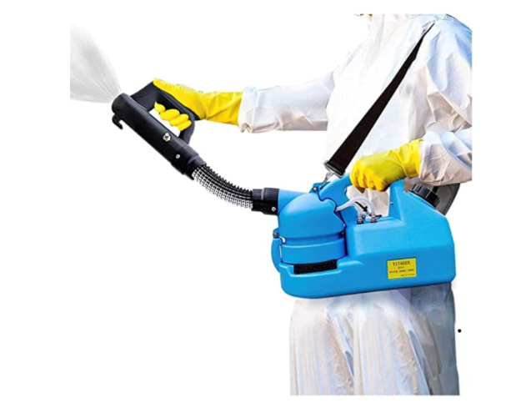
- We have an electrostatic sprayer to sanitize the facility
- Everyone besides basketball players and officials must wear a mask
- We have three sanitation stations throughout the court
- Taking temperatures of everyone entering the facility
- We are not allowing more than 4 people per athlete to watch the game.
- We are practicing social distancing
- We are provided weekly updates by our local officials
- We are selling masks for $5.00 and gloves for $3.00 for anyone who forgets to bring one.
- We have a cap on the number of spectators allowed in the facility
- We are doing as much online to avoid face to face interaction
- We are sanitizing high traffic areas frequently throughout the day.

What is SOA doing to combat COVID?

www.soasatx.com

SOA is a 501 (c) 3 youth-oriented athletics association specializing in the growth and development of our future citizens. The organization is made up of volunteer parents, coaches and administrators. SOA focuses on activities including, but not limited to team building, instruction and developmental camps, agility training, nutrition and citizenship. The mission of SOA is to strengthen the individual, family and community through educational enrichment and fitness programs.
Team Information

And
- Teams are based on the player’s age as of September 1st, 2020, of the current school year.
- Minimum of 7 players*, maximum of 10 players* per most sports teams. (*Suggested player minimums and maximums will vary for soccer, and volleyball.
- Coaches may request extended rosters, if registering a full team.
- Coach and friend requests will be accommodated as space allows. Special requests (team placement, game days, etc.) are NOT GUARANTEED.
- Most teams are coed. There are limited all-girls teams; girls’ 10U and 12U. Teams can play against boys.
- There is a $3.00 fee to enter the gym. This fee applies to everyone above the age of 3 years old.
- Masks and hand sanitation are mandatory for everyone entering the facility above the age of three. Players and officials are the only individuals to be without a mask.
www.soasatx.com

- Due to the current pandemic, SOA will not be providing practice sites. The coach may utilize any outdoor basketball court or private facility at their own discretion. NEISD, NISD and all San Antonio Independent School Districts have outdoor basketball courts that are available for you to use.
- If you are interested in purchasing a practice site, please contact our office at 210-775-2807 and we will assist you in finding a practice location.
- Coaches are responsible for notifying their team of decided practice location.
Practice Information
Game Information

- Season is eight (8) weeks and will consist of 7 regular season games & at least 1 tournament game. No games will be played on holidays. (Spring is 7 weeks)

- Please check the SOA website for your team’s game & practice information EVERY FRIDAY to confirm dates, times, and locations.

- Game locations will remain at SOA for the duration of the season (Unless a location has a prior event or if there are not enough teams to support its self, then games will be combined with other leagues. If there is an unforeseen event, games will be held at The Christian School at Castle Hills).

- Please arrive 30 minutes prior to game time. Please do not enter the facility until the game in session has ended. Outdoor seating will be provided by SOA.

- SEE WEBSITE FOR ALL AGE/DIVISION RULES: http://www.soasatx.com/soa-basketball-rules.html.

- Please remain in communication with your team’s coaching staff regarding practice, meetings, and games.

www.soasatx.com

woasatx.com

- Tournament format is single elimination with each team playing a minimum of 1 game.
- All teams in each age/division will participate in the end of season tournament.
- Tournament games will be played on Friday evening, Saturday and Sunday.
- Teams may play multiple games in a day.
- Tournament seeding is based on regular season standings.
- Special opportunities to play additional games/matches may be provided throughout the sports season! Please be aware that emails may be sent regarding game day, time, and locations of special game opportunities!

www.soasatx.com
Tournament Information

All coaches, parents, and players are required to sign the SOA Code of Conduct. All coaches are required submit to a full background check. This helps to ensure a fair, safe, and fun environment for everyone involved. If at any time you feel someone is not following this code, please contact an SOA staff member immediately and appropriate action will be taken. If anyone refuses to wear a mask, they will be escorted out immediately. If anyone’s temperature is above 99.3 degrees, they will not be able to enter.

SOCIAL MEDIA-Conduct yourself online just as you would in any other public circumstances. Treat those you encounter online with fairness, honesty and respect, just as you would offline. If found badmouthing, using vulgar language or exhibiting a lack of respect to any teams in the league or our staff, you will be suspended indefinitely.

WE HAVE A ZERO TOLERANCE POLICY; MEASURES WILL BE TAKEN IF SOA’S CODE OF CONDUCT IS BROKEN. ANYONE BREAKING THE CODE OF CONDUCT WILL BE ESCORTED OFF THE PREMISES AND WILL ONLY BE ALLOWED TO RETURN AT THE DISCRESTION OF THE LEAGUE DIRECTOR.

www.soasatx.com

ww

Code of Conduct
Calendar of Events
Calendar of Events Spring 2021 Season:
- April 2nd from 7pm – 9pm Coaches Meeting
- First day to start submitting report cards for scholar athlete: N/A
- First 2 weeks of schedule posted: April 2nd
- 1st weekend of Basketball games: April 10th and 11th
- 2nd week of Basketball: 17th and 18th
- Last 5 weeks of season schedule will be out:
- 3rd week of Basketball: April 24th and April 25th
- 4th week of Basketball: May 1st and May 2nd
- 5th week of Basketball: May 8th and May 9th
- Deadline to submit reports cards for scholar athlete: N/A
- 6th week of Basketball: May 15th and May 16th
- Basketball Tournament Weekend: May 15th – May 23rd

www.soasatx.com
Volunteer Opportunities

Parent first, volunteer second.
Volunteers are needed in a variety of areas within SOA. Some of these needs include:
-Coaches (Must register online as a volunteer)
-Assistant Coaches (Must register online as a volunteer)
-Team Parent (Registration online not required)

www.soasatx.com

Parent’s Code of Conduct
I hereby pledge to provide positive support, care, and encouragement for my child participating in SOA by following this Parents’ Code of Conduct.
- I (and my guests) will encourage good sportsmanship by demonstrating positive support for all players, coaches, and officials at every game, practice or other SOA event.
- I (and my guests) will not engage in any kind of unsportsmanlike conduct with any official, coach, player, or parent such as booing and taunting, refusing to shake hands, arguing calls or coaching decisions, or using profane language or gestures.
- I will place the emotional and physical well-being of my child ahead of my personal desire to win.
- I will never ridicule or yell at my child or other participant for making a mistake of losing a competition.
- I will insist that my child play in a safe and healthy environment.
- I will require that my child’s coach be trained in the responsibilities of being an SOA coach and that the coach upholds the Coach’s Code of Conduct.
- I will support coaches and officials working with my child, in order to encourage a positive and enjoyable experience for all.
- I will demand a sports environment for my child that is free from drugs, tobacco, and alcohol, and I will refrain from their use at all SOA events.
- I will remember that the game is for youth - NOT adults.
- I will do my very best to make youth sports fun for my child.
- I will ask my child to treat other players, coaches, fans, and officials with respect regardless of race, sex, creed or ability, and expect the same in return.
- I will help my child enjoy the SOA experience by doing whatever I can, such as being a respectful fan, assisting with coaching, or providing transportation.
- I understand that SOA staff, director and organization is not responsible for any COVID related illnesses.
SOCIAL MEDIA
Conduct yourself online just as you would in any other public circumstances. Treat those you encounter online with fairness, honesty and respect, just as you would offline. If found badmouthing, using vulgar language or lacking respect to any teams in the league, you will be suspended indefinitely.

WE HAVE A ZERO TOLERANCE POLICY; MEASURES WILL BE TAKEN IF CODE OF CONDUCT IS BROKEN. ANYONE BREAKING THE CODE OF CONDUCT WILL BE ESCORTED OFF THE PREMISES AND WILL NOT BE ALLOWED TO RETURN AND WILL ONLY BE ALLOWED TO RETURN AT THE DISCRETION OF THE LEAGUE DIRECTOR.

I understand that I must abide by the above Code of Conduct. If I do not follow the SOA Parent’s Code of Conduct, I will be subject to disciplinary action that could include, but is not limited to, the following: verbal warning by official, coach, or SOA director; ejection from game facilities; parental game suspension, game forfeit; or season suspension with no refund of fees.
_____________________ _____________________
Player’s Name Date
_____________________ _____________________
Parent’s Name Signature

